**EXPERIMENT NO: - 03**

Name:- Akruti Dabas Class:- D15A Roll:No: - 11

**AIM:**

To include icons, images, fonts in Flutter app.

**THEORY:**

Flutter is a versatile open-source UI framework , which allows developers to build natively compiled applications for mobile, web, and desktop platforms from a single codebase. One of the key strengths of Flutter is its flexibility in creating highly customizable UIs. This practical focuses on incorporating essential visual elements—icons, images, and custom fonts—into a Flutter application. These elements enhance the visual appeal and usability of the app, providing an engaging experience for users. A flutter app when built has both assets (resources) and code. Assets are available and deployed during runtime. The asset is a file that can include static data, configuration files, icons, and images. The Flutter app supports many image formats, such as JPEG, WebP, PNG, GIF, animated WebP/GIF, BMP, and WBMP. Visual elements play a significant role in app development.

**•Enhanced User Experience:** Images and icons make your app visually appealing and user friendly.

**• Information Conveyance:** They convey information quickly and intuitively. A well chosen icon can replace lengthy text.

**•Branding:** Custom icons and images reinforce your app's branding, making it memorable.

**➢ Adding Icons in Flutter**

Flutter provides built-in material design icons through the Icons class. Custom icons can also be added using third-party packages such as flutter_launcher_icons and font_awesome_flutter. Icon( Icons.home, size: 40, );

➢ Adding Images in Flutter

Flutter supports images from three sources:

1. Assets (Stored locally in the project)

• Place the image inside the assets/images folder in the project.

• Declare the image in pubspec.yaml flutter: assets: - assets/images/sample.png

• Display the image in the app Image.asset('assets/images/sample.png');

2. Network (Fetched from the internet) Displaying images from the internet or network is very simple. Flutter provides a built-in method Image.network to work with images from a URL. The Image.network method also allows you to use some optional properties, such as height, width, color, fit, and many more. Image.network('https://example.com/sample.jpg'); 3. Memory or File (Stored on the device)

➢ Adding Custom Fonts in Flutter By default, Flutter uses the Roboto font, but custom fonts can be added for a unique UI.

• Download the font and place it in the assets/fonts/ folder.

• Declare the font in pubspec.yaml

• Use the font in the app Text( 'Custom Font Example', style: TextStyle(fontFamily: 'CustomFont', fontSize: 24), );

**CODE:**

**CUSTOM_TEXT_FIELD.DART**

import 'package:flutter/material.dart';

class CustomTextField extends StatelessWidget {

  final String hint;

  final IconData icon;

  final bool obscureText;

  final IconData? suffixIcon;

  final TextEditingController? controller; // Add this line

  const CustomTextField({

    Key? key,

    required this.hint,

    required this.icon,

    required this.obscureText,

    this.suffixIcon,

    this.controller, // Add this line

  }) : super(key: key);

  @override

  Widget build(BuildContext context) {

    return TextField(

      controller: controller, // Use the controller here

      obscureText: obscureText,

      style: const TextStyle(color: Colors.white),

      decoration: InputDecoration(

        hintText: hint,

        hintStyle: const TextStyle(color: Colors.grey),

        filled: true,

        fillColor: Colors.grey[900],

        prefixIcon: Icon(icon, color: Colors.white),

        suffixIcon:

            suffixIcon != null ? Icon(suffixIcon, color: Colors.white) : null,

        border: OutlineInputBorder(

          borderRadius: BorderRadius.circular(8),

          borderSide: BorderSide.none,

        ),

      ),

    );

  }

}

**INSPIRATION.DART**

import 'package:flutter/material.dart';

class InspirationScreen extends StatelessWidget {

  const InspirationScreen({Key? key}) : super(key: key);

  @override

  Widget build(BuildContext context) {

    return Scaffold(

      backgroundColor: Colors.grey[900],

      appBar: AppBar(

        backgroundColor: Colors.transparent,

        elevation: 0,

        leading: IconButton(

          icon: const Icon(Icons.arrow_back, color: Colors.white),

          onPressed: () => Navigator.pop(context),

        ),

      ),

      body: Padding(

        padding: const EdgeInsets.all(16.0),

        child: Column(

          crossAxisAlignment: CrossAxisAlignment.start,

          children: [

            const Text(

              'Spark your\nnext idea',

              style: TextStyle(

                color: Colors.white,

                fontSize: 28,

                fontWeight: FontWeight.bold,

              ),

            ),

            const SizedBox(height: 16),

            const Text(

              'Explore beautiful work,\nmade on Fiverr, picked for you.',

              style: TextStyle(color: Colors.grey, fontSize: 16),

            ),

            const SizedBox(height: 24),

            SizedBox(

              height: 100,

              child: ListView(

                scrollDirection: Axis.horizontal,

                children: [

                  _buildCategoryCard('All', const Color(0xFF4A64FE)),

                  const SizedBox(width: 12),

                  _buildCategoryCard('Top Trending', Colors.green),

                  const SizedBox(width: 12),

                  _buildCategoryCard('For You', const Color(0xFFE068A8)),

                ],

              ),

            ),

            const SizedBox(height: 24),

            Row(

              mainAxisAlignment: MainAxisAlignment.spaceBetween,

              children: [

                const Text(

                  'Book Design',

                  style: TextStyle(

                    color: Colors.white,

                    fontSize: 18,

                    fontWeight: FontWeight.bold,

                  ),

                ),

                ElevatedButton.icon(

                  onPressed: () {},

                  icon: const Icon(Icons.add, color: Colors.white),

                  label: const Text('Follow',

                      style: TextStyle(color: Colors.white)),

                  style: ElevatedButton.styleFrom(

                    backgroundColor: Colors.green,

                    shape: RoundedRectangleBorder(

                      borderRadius: BorderRadius.circular(8),

                    ),

                  ),

                ),

              ],

            ),

            const SizedBox(height: 16),

            Expanded(

              child: GridView.count(

                crossAxisCount: 2,

                crossAxisSpacing: 12,

                mainAxisSpacing: 12,

                childAspectRatio: 0.75,

                children: [

                  _buildBookCard('assets/images/book_design_1.jpg', 427),

                  _buildBookCard('assets/images/book_design_2.jpg', 334),

                  _buildBookCard('assets/images/book_design_1.jpg', 427),

                  _buildBookCard('assets/images/book_design_2.jpg', 334),

                ],

              ),

            ),

          ],

        ),

      ),

    );

  }

  Widget _buildCategoryCard(String title, Color color) {

    return Container(

      width: 120,

      decoration: BoxDecoration(

        color: color,

        borderRadius: BorderRadius.circular(12),

      ),

      child: Center(

        child: Text(

          title,

          style: const TextStyle(

            color: Colors.white,

            fontSize: 16,

            fontWeight: FontWeight.bold,

          ),

        ),

      ),

    );

  }

  Widget _buildBookCard(String imagePath, int awards) {

    return Container(

      decoration: BoxDecoration(

        color: Colors.grey[800],

        borderRadius: BorderRadius.circular(12),

      ),

      child: Column(

        crossAxisAlignment: CrossAxisAlignment.start,

        children: [

          Expanded(

            child: ClipRRect(

              borderRadius: const BorderRadius.only(

                topLeft: Radius.circular(12),

                topRight: Radius.circular(12),

              ),

              child: Image.asset(

                imagePath,

                width: double.infinity,

                fit: BoxFit.cover,

              ),

            ),

          ),

          Padding(

            padding: const EdgeInsets.all(8.0),

            child: Row(

              mainAxisAlignment: MainAxisAlignment.spaceBetween,

              children: [

                Text(

                  '$awards awards',

                  style: const TextStyle(color: Colors.grey, fontSize: 12),

                ),

                const Icon(Icons.favorite_border, color: Colors.white),

              ],

            ),

          ),

        ],

      ),

    );

  }

}

**HOME_PAGE.DART**

import 'package:flutter/material.dart';

class HomeScreen extends StatefulWidget {

  const HomeScreen({Key? key}) : super(key: key);

  @override

  _HomeScreenState createState() => _HomeScreenState();

}

class _HomeScreenState extends State<HomeScreen> {

  int _selectedIndex = 0;

  void _onItemTapped(int index) {

    setState(() {

      _selectedIndex = index;

      if (index == 4) {

        // Index 4 is the profile icon

        Navigator.pushNamed(context, '/profile');

      }

      if (index == 1) {

        // Index 4 is the profile icon

        Navigator.pushNamed(context, '/inbox');

      }

    });

  }

  @override

  Widget build(BuildContext context) {

    return Scaffold(

      backgroundColor: Colors.black,

      appBar: AppBar(

        backgroundColor: Colors.black,

        elevation: 0,

        title: Row(

          children: [

            const Text(

              'fiverr.',

              style: TextStyle(

                color: Colors.green,

                fontSize: 24,

                fontWeight: FontWeight.bold,

              ),

            ),

            const Spacer(),

            IconButton(

              icon: const Icon(Icons.diamond_outlined, color: Colors.white),

              onPressed: () {},

            ),

          ],

        ),

      ),

      body: Padding(

        padding: const EdgeInsets.all(16.0),

        child: Column(

          crossAxisAlignment: CrossAxisAlignment.start,

          children: [

            // Search Bar

            Container(

              decoration: BoxDecoration(

                color: Colors.grey[900],

                borderRadius: BorderRadius.circular(8),

              ),

              child: const TextField(

                style: TextStyle(color: Colors.white),

                decoration: InputDecoration(

                  hintText: 'Search services',

                  hintStyle: TextStyle(color: Colors.grey),

                  prefixIcon: Icon(Icons.search, color: Colors.grey),

                  border: InputBorder.none,

                  contentPadding: EdgeInsets.all(12),

                ),

              ),

            ),

            const SizedBox(height: 20),

            // Popular Services

            Row(

              mainAxisAlignment: MainAxisAlignment.spaceBetween,

              children: [

                const Text(

                  'Popular Services',

                  style: TextStyle(

                    color: Colors.white,

                    fontSize: 18,

                    fontWeight: FontWeight.bold,

                  ),

                ),

                TextButton(

                  onPressed: () {},

                  child: const Text(

                    'See All',

                    style: TextStyle(color: Colors.green),

                  ),

                ),

              ],

            ),

            const SizedBox(height: 10),

            // Grid of Services

            SizedBox(

              height: 160, //Adjusted Height

              child: ListView(

                scrollDirection: Axis.horizontal,

                children: [

                  _buildServiceCard(

                    'Logo Design',

                    'assets/images/logo_design.jpg',

                  ),

                  const SizedBox(width: 10),

                  _buildServiceCard(

                    'AI Artists',

                    'assets/images/ai_artists.jpg',

                  ),

                  const SizedBox(width: 10),

                  _buildServiceCard(

                    'Logo Design',

                    'assets/images/logo_design.jpg', //Sample

                  ),

                ],

              ),

            ),

            const SizedBox(height: 20),

            // Made on Fiverr Section

            const Text(

              'Made on Fiverr',

              style: TextStyle(

                color: Colors.white,

                fontSize: 18,

                fontWeight: FontWeight.bold,

              ),

            ),

            const SizedBox(height: 10),

            // Second Grid

            SizedBox(

              height: 190, //Adjusted height

              child: GridView.count(

                crossAxisCount: 3,

                crossAxisSpacing: 8,

                mainAxisSpacing: 8,

                childAspectRatio: 1, // Keep aspect ratio 1:1

                physics:

                    const NeverScrollableScrollPhysics(), // Disable scrolling within the grid

                children: List.generate(6, (index) {

                  return Container(

                    decoration: BoxDecoration(

                      borderRadius: BorderRadius.circular(8),

                      image: DecorationImage(

                        image: AssetImage(

                          'assets/images/made_on_fiverr_${index + 1}.jpg',

                        ), // Example: made_on_fiverr_1.jpg

                        fit: BoxFit.cover,

                      ),

                    ),

                    child: index == 0

                        ? Align(

                            alignment: Alignment.topLeft,

                            child: Container(

                              padding: const EdgeInsets.all(4),

                              decoration: BoxDecoration(

                                color: Colors.black.withOpacity(0.7),

                                borderRadius: const BorderRadius.only(

                                  topLeft: Radius.circular(8),

                                  bottomRight: Radius.circular(8),

                                ),

                              ),

                              child: const Text(

                                'MADE ON FIVERR',

                                style: TextStyle(

                                  color: Colors.white,

                                  fontSize: 10,

                                ),

                              ),

                            ),

                          )

                        : null, // Show "MADE ON FIVERR" on the first item

                  );

                }),

              ),

            ),

          ],

        ),

      ),

      bottomNavigationBar: BottomNavigationBar(

        backgroundColor: Colors.grey[900],

        selectedItemColor: Colors.green,

        unselectedItemColor: Colors.white,

        items: const [

          BottomNavigationBarItem(icon: Icon(Icons.home), label: ''),

          BottomNavigationBarItem(icon: Icon(Icons.mail), label: ''),

          BottomNavigationBarItem(icon: Icon(Icons.search), label: ''),

          BottomNavigationBarItem(icon: Icon(Icons.list), label: ''),

          BottomNavigationBarItem(icon: Icon(Icons.person), label: ''),

        ],

        type: BottomNavigationBarType.fixed,

        currentIndex: _selectedIndex, // Set current index

        onTap: _onItemTapped, // Call this function when item is tapped

      ),

    );

  }

  Widget _buildServiceCard(String title, String imagePath) {

    return Container(

      width: 130, //Adjusted width of card

      decoration: BoxDecoration(

        color: Colors.grey[900],

        borderRadius: BorderRadius.circular(12), // Adjusted radius

      ),

      child: Column(

        crossAxisAlignment: CrossAxisAlignment.start,

        children: [

          ClipRRect(

            borderRadius: const BorderRadius.only(

              topLeft: Radius.circular(12),

              topRight: Radius.circular(12),

            ),

            child: Image.asset(

              imagePath,

              height: 100, // Adjusted Height

              width: double.infinity,

              fit: BoxFit.cover,

            ),

          ),

          Padding(

            padding: const EdgeInsets.all(8.0),

            child: Text(

              title,

              style: const TextStyle(color: Colors.white, fontSize: 12),

            ),

          ),

        ],

      ),

    );

  }

}

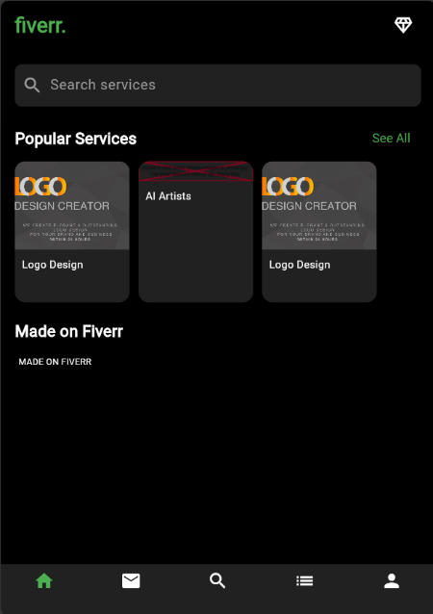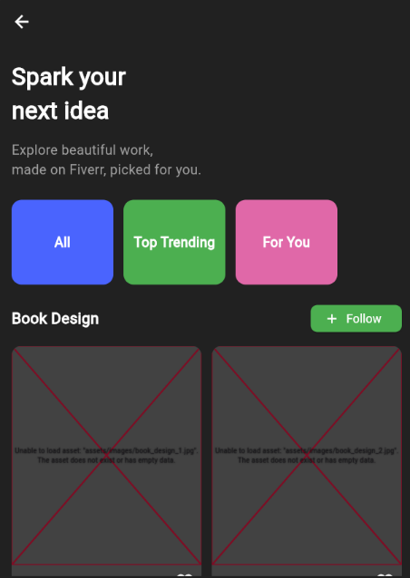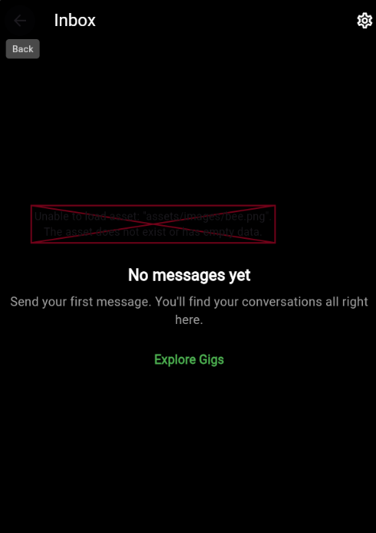**OUTPUT:**